Easy way to set-up Prisma to SQLite

Prisma docs link: <https://www.prisma.io/docs>

To install Prisma through npm command in next js project folder:

npm install prisma –save-dev

set up Prisma with the init command of the Prisma CLI:

To set up to sqlite

npx prisma init --datasource-provider sqlite

This creates a new prisma directory with your Prisma schema file and configures SQLite as your database. You're now ready to model your data and create your database with some tables.

After setting up the Prisma there is a Prisma folder is created under a file is created called schema.prisma

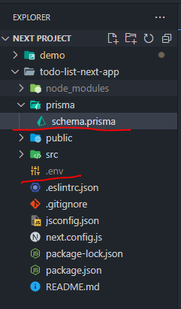

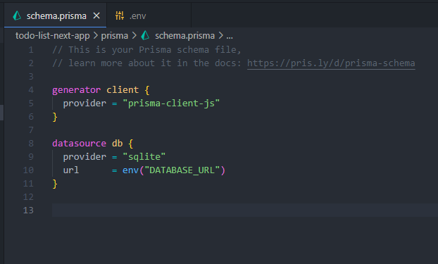

Default prisma file

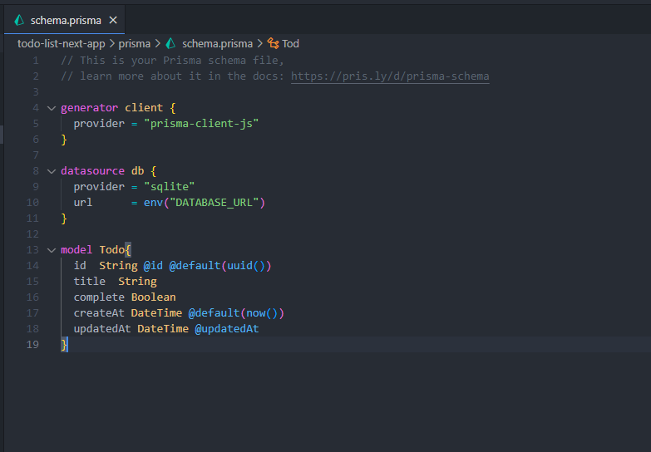

Created a model called Todo

After creating model we have to migrate

npx prisma migrate dev --name init

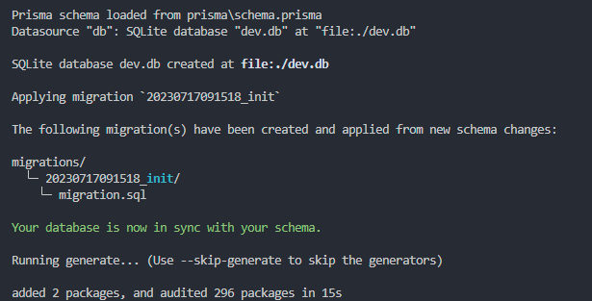

Then creating db.ts:

Note this prisma should be created with ts extension becaue it only support ts files

import { PrismaClient } from "@prisma/client";

const globalForPrisma = global as unknown as {

    prisma: PrismaClient | undefined

}

export const prisma =

    globalForPrisma.prisma ??

    new PrismaClient({

        log:['query'],

    })

if(process.env.NODE_ENV !== 'production') globalForPrisma.prisma = prisma